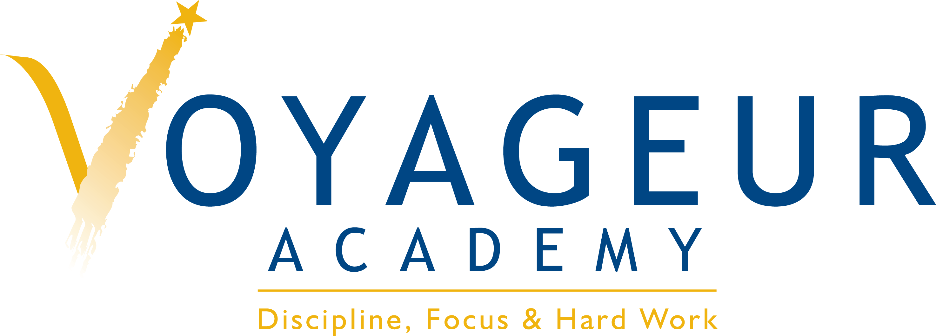

Voyageur Academy/Consortium College Preparatory High School
Lobbying Costs Transparency Report
FY 2014-2015

As per the fiscal year adopted budget, the District does not plan to incur any lobbying expenditures for the period 2014-2015.

